Underwater ROV Decision Guide for Maine Marinas
Cut Inspection Costs by 75% While Eliminating Diver Risk

PAGE 1: The $20,000+ Problem Hidden Underwater
Every Maine marina faces the same expensive reality: critical infrastructure lives where you can't see it. Your dock pilings, moorings, and seawalls, the foundation of your entire operation deteriorate silently underwater until failure becomes catastrophic.
Inspection Method | Annual Cost | Response Time | Weather Dependent
Professional Diver | $9,000-30,000 | 1-3 days | Yes
Emergency Diver | $1,500-5,000/call | 24-72 hours | Yes
ROV System | $200 (electricity) | 30 minutes | No

Maine's 2024 winter storms caused $90 million in marine infrastructure damage ¹, with most facilities unable to assess damage for weeks due to diver availability and weather constraints. One local marina discovered its pilings had deteriorated to "toothpicks" during routine maintenance. It was nearly too late to prevent dock collapse and unlimited liability exposure.
The Three Hidden Costs Killing Your Bottom Line:
- Inspection Frequency Gap: Insurance guidelines require inspections every 5 years minimum, but divers cost $1,500-$5,000 per day ²
- Weather Delays: Maine's extreme tidal range and winter conditions interrupt dive operations often through the year
- Emergency Premium: Storm damage assessment at emergency rates doubles or triples normal costs
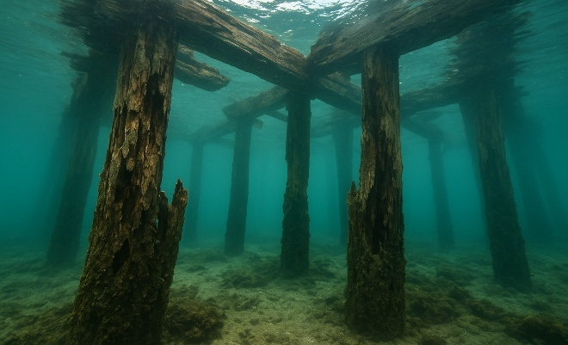
Quick ROV Assessment (Check all that apply):
□ You manage 30+ slips or 15+ moorings
□ You spend $3,000+ annually on diving services
□ You've discovered problems too late before
□ You need immediate storm damage documentation
□ Your infrastructure is over 10 years old
If you checked 2+ boxes, ROV investment will transform your operations with 4 to 10-month payback.
PAGE 2: What ROVs Actually Do for Maine Marinas
Primary Applications That Pay for Themselves:
Infrastructure Monitoring (Weekly vs. Semi-Annual)
- Inspect pilings for marine borer damage and structural cracks
- Check mooring chains, shackles, and concrete blocks
- Monitor seawalls for undermining and concrete spalling
- Detect fuel line leaks before environmental disasters
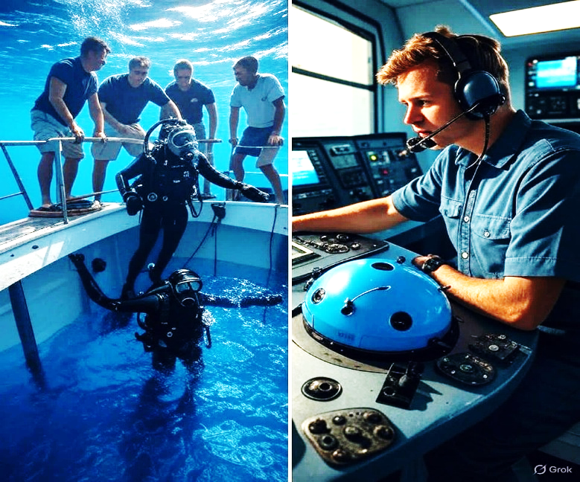
Emergency Response (30 Minutes vs. 3 Days)
- Document grounding damage for insurance within hours
- Assess storm damage immediately for FEMA claims
- Recovering dropped equipment without diver callout
- Investigate environmental incidents instantly

Real Numbers from Real Maine Operations:

- Case Study: 80-Slip Marina Annual Savings
- Previous: 6 diver inspections × $3,000 = $18,000/year
- Current: Weekly ROV inspections × $5 electricity = $260/year
- Additional prevented losses: $15,000 (early piling detection)
- Total first-year benefit: $32,740

Professional inspection companies now use ROVs themselves, with UCC reporting 70% cost reductions³ and faster completion rates compared to traditional diving. Insurance companies increasingly recognize ROV programs as risk mitigation, potentially reducing premiums while eliminating extremely high workers compensation exposure costs associated with commercial diving.

PAGE 3: Your Investment Options & ROI Timeline
Professional ROV Systems for Marina Operations:
Model | Price | Best For | Depth Rating | Payback Period
FIFISH V-EVO | $3,499 | Small marinas (<50 slips) | 330ft | 6-8 months
BlueROV2 | $4,500 | Tech-savvy operators | 330ft | 8-10 months
Deep Trekker DTG3 | $8,500-15,000 | Most marinas | 650ft | 8-12 months
Deep Trekker Pivot | $17,000-25,000 | Strong currents | 980ft | 10-14 months

All systems include 4K cameras, operate in Maine's 32-40°F water, and handle 2+ knot currents standard in Maine harbors.
Financial Analysis:
Traditional Diving (3 Years):
- Annual inspections (6/year): $45,000
- Emergency calls (2/year): $12,000
- Weather delays: $3,000
- Total: $60,000
ROV System (3 Years):
- Equipment: $15,000
- Training (one-time): $2,000
- Maintenance: $3,000
- Total: $19,500
- Savings: $40,500

PAGE 4: Revenue Opportunities:
- Mooring inspections for customers: $75/inspection
- Pre-haul hull checks: $150/vessel
- Insurance documentation: $300/incident
- Neighboring marina services: $500/visit
Implementation Roadmap
Week 1: Equipment & Training
Recommended Maine Suppliers:
- Hamilton Marine (Southwest Harbor, Searsport, Portland)
- Online direct from manufacturers with 2-day shipping
Training Requirements:
- 4 hours pool/calm water practice
- 2 hours equipment familiarization
- No certification required (unlike commercial diving)
Week 2-4: Develop Procedures
Standard Operating Procedures:
- Weekly quick inspection (30 minutes)
- Monthly comprehensive survey (2 hours)
- Storm response protocol
- Video storage system (1TB drive = 1 year of inspections)
Month 2-6: Maximize ROI
Cost Reduction Targets:
- Reduce diver visits by 75%
- Eliminate emergency dive calls
- Catch problems 12-18 months earlier
- Document everything for insurance

PAGE 5: Funding & Support Resources:
Grants Available NOW:
- Maine DEP Shore & Harbor Planning Grants (up to $50,000) ⁴
- Small Harbor Improvement Program (up to $250,000, 50% match) ⁵
- FEMA disaster recovery funds (2024 storms)
- Maine Technology Institute equipment grants
Insurance Benefits:
- Documented maintenance programs improve rates
- Video evidence strengthens claims
- Eliminated diving liability exposure
- Proactive risk management recognition
Final Decision Framework:
Buy a ROV This Month If:
- You manage 30+ slips or 15+ moorings
- You spend $3,000+ annually on diving
- You've had one near-miss with infrastructure and/or diver safety
- You want to offer premium services
Wait If:
- You have <20 slips
- All infrastructure is <5 years old
- You have a reliable diver on retainer for <$1,000/inspection

Contact: Geoff King | geoffrey.king@maine.edu | University of Maine Student Technology Research
Sources: ¹ National Fisherman, "Rebuilding in Maine" (2024) and News Center Maine storm damage reports; ² Professional diver rates from PayScale/Salary.com 2024-2025 data; ³ UCC Dive and Deep Trekker ROV case studies; ⁴ Maine DEP Coastal Program grants; ⁵ Maine DOT Small Harbor Improvement Program
This guide was developed through interviews with Maine marina operators and analysis of industry cost data following the 2024 storm damage crisis.

